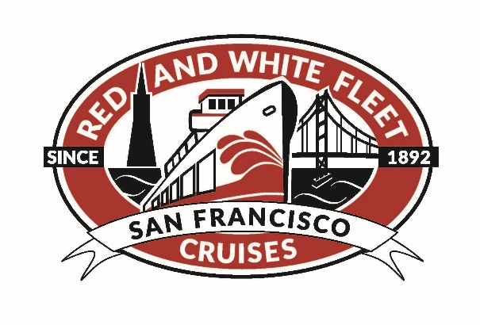

Position Title: Food and Beverage Manager
Department: Guest Services
Reports To: Managing Directors
Projected Work Schedule and Hours: Full time-schedule and hours vary based on business needs – weekend work required.
Position Summary
The primary responsibility of the Food and Beverage Manager is to oversee our bar and concessions operations on the vessels to ensure our customers have the best experience possible when sailing with us on San Francisco Bay.
Qualifications Required
• Associates or Bachelor’s degree with a focus on Hospitality preferred.
• 2-3 years of experience in a supervisory or leadership role in a business environment preferred.
• Sales, customer service, POS and cash handling and bartending experience required. 21+ only.
Success Factors and Job Competencies
Service: Welcoming, kind, considerate, accessible, charitable, and communicative.
Enthusiasm: Energetic, interested, involved, and optimistic
Responsibility: Accountable, intentional and reliable
Vision: Innovative, resourceful, inventive, curious, flexible, and creative
Integrity: Honest, thoughtful, respectful, lawful, and earnest
Collaboration: Cooperative, supportive and appreciative
Efficiency: Organized, professional, environmental, profitable, practical, and prudent
Essential Functions and Responsibilities
- Perform bartending duties aboard cruises. Mix and pour drinks, sell drinks and snacks from the bar menu.
- Assure proper and adequate staffing of bartenders
- Recruit and hire staff
- Draft annual departmental budgets for review with Site Manager and Managing Directors
- Orient and train to performance expectations
- Provide ongoing supervision, coaching and development
- Manage performance quality and improvement
- Provide performance review, evaluation, and recognition
- Assure accurate records are maintained by conducting routine physical inventories and recording those numbers
- Train staff in restock and inventory control procedures
- Place, receive and distribute orders assuring loss controls are in place and observed
- Maintain accurate records and reconcile with Accounting Dept.
- Product management; high demand products, proper point of sale pricing and high cost to revenue margins
- Assure bars are maintained to health code standards, maintain successful health inspections
- Train staff in proper cleaning and storage techniques
- Implement creative marketing, display, and sales methods on a regular basis
- Implement weekly cleaning and daily recycling task list for bartenders
- Maintain a clean storage area by actively cleaning and organizing storage areas
- Maintains binder with all Bartenders CA food handler cards
- Event Cruise Coordination:
- Act as liaison with client on event details
- Review event details with Captain and Crew during set up to assure all expectations are met
- Coordinate with entertainers to ensure that timing and expectations are met
- Review food order details with caterers to assure all items and quantities are accurate
- Assure that bar staff is properly stocked and prepared for event –review IDing passengers, cutting off intoxicated guests, timing of closure of bar, etc.
Physical demands and Working Environment:
- The physical demands and work environment described here are representative of those that must be met by an employee to successfully perform the essential functions of this job.
- Reasonable accommodation may be made to enable individuals with disabilities to perform the essential functions.
Physical demands:
- While performing the duties of this job, the employee is required to stand; walk; sit; use hands to fingers; reach with hands and arms; talk and hear.
- This employee must occasionally be able to lift 50 pounds.
- This employee must be able to independently travel
Work Environment:
- Must sometimes work outdoors in crowded areas and on boats in a marine environment
- Temperature and climate may vary
- Moderate noise level

